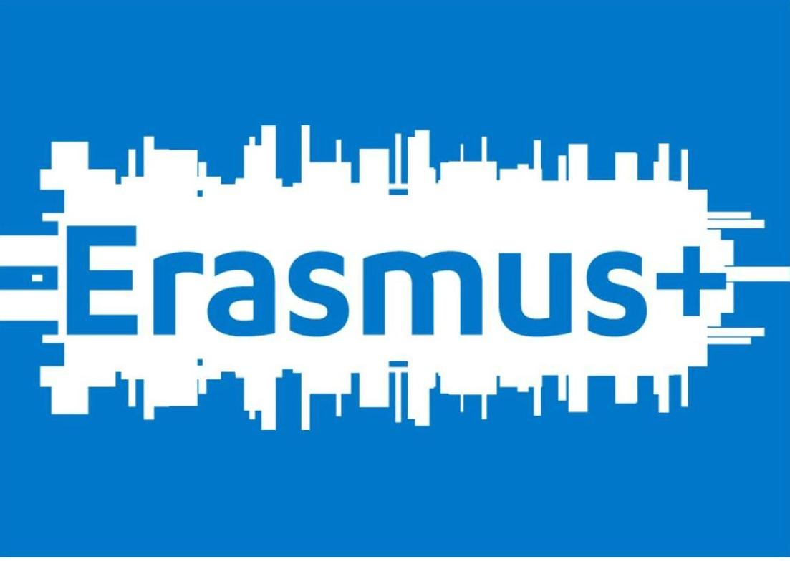
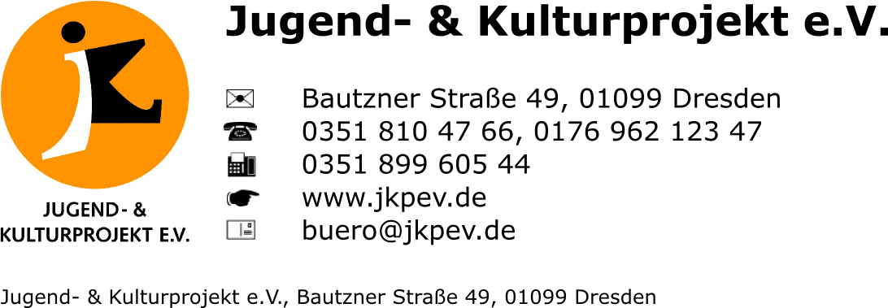
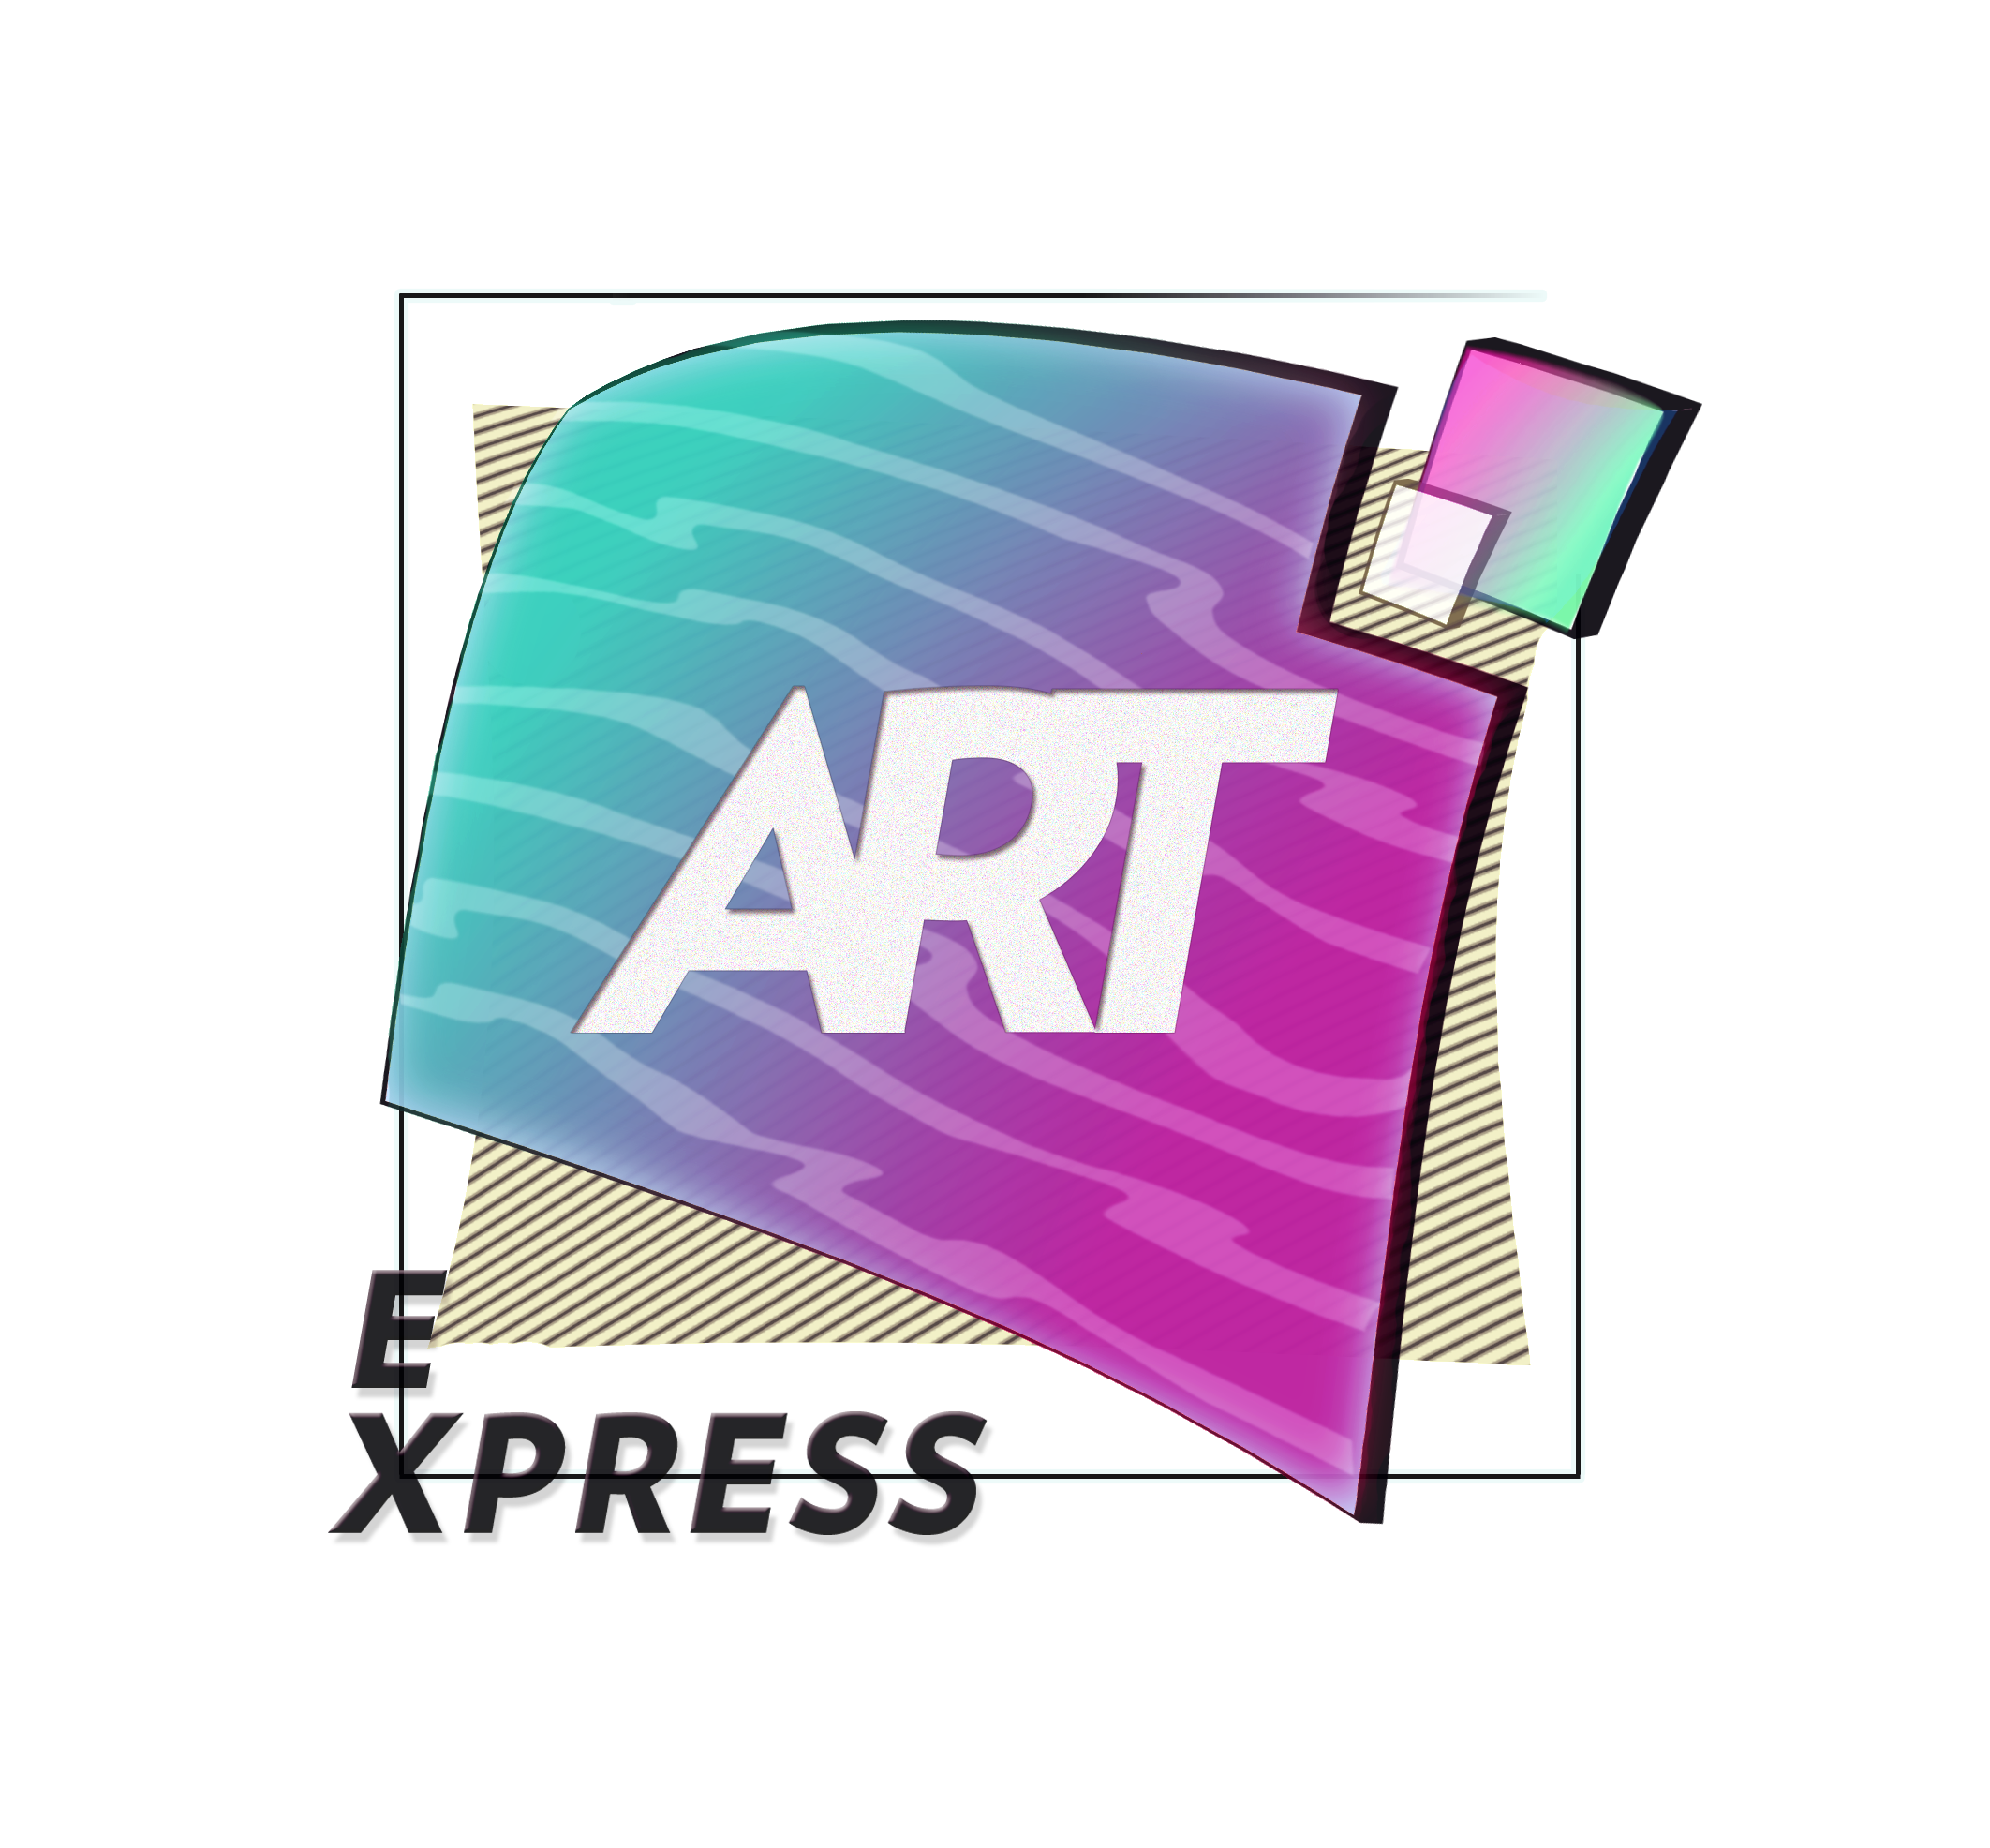

Training Course
Dresden, Germany

2 – 9 July 2015

APPLICANT PERSONAL DATA

Before filling out the registration form, please read carefully the info pack!

Partner organization:
First Name:
Family name:
Date of Birth:
Gender: | Female |  |  | Male
Tel. number:
Mob. number:
Fax:
E-mail:
Facebook:
Address: | Street name
Address: | Postcode
Address: | Region
Address: | City
Address: | Country
Emergency contact: | Name
Emergency contact: | Mobile
Dietary needs:

Please describe your English language skills

What is the field of your work?

What is your experience and knowledge of visual arts?

Have you ever used visual arts as a learning tool in youth work? If yes, can you explain how you achieved it?

Why would you like to participate in ArtExpress training course? What are your expectations?

Have you participated in other training courses of Erasmus+ programme and if yes in which ones?

Have you coordinated or led any youth exchanges, training course of Erasmus+ programme? If yes, please describe up to two projects.

How can you contribute to the ArtExpress training course? What can you share with the rest of the group (team-building activities, energizers, workshops etc.)?

How are you going to disseminate the results and the learning outcomes of ArtExpress training course

Please let us know if you can bring a lap top, a photo/video camera, memory card and USB sticks for the training course

Please fill out the registration form and send it to to mtyspeaknow@gmail.com

